

# Laser 7 inches Android 10

## Type of device: Tablet

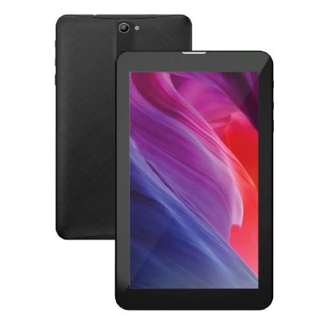

Actual Display Size : 7 inches

Operating System : Google Android

Version Number : Android 10

Average Price : $100 as of 01 07 2021

Internet Access : Wi-Fi Only

## Accessibility Features:

### Cognitive

* Additional Instructions
* Copy and Paste
* Flicker Free Display
* GPS
* Photo Telephone List
* Screen Timeout Disabled
* Simple Instructions
* Simple Reminders
* Simplify Display

Voice Notes

### Hearing Impairment and Deaf

* Allows for sign language communication
* Bluetooth or Wi-Fi
* Closed Captioning
* Front Facing Camera
* Video Communications - Two-way

Visual Alerts - Incoming Calls

### Vision

* Accessibility APIs supported
* Battery Alert - Audible
* Bluetooth or Wi-Fi
* Braille Display Support
* Brightness Adjustable
* Dictation / Speech-to-Text
* High Contrast Mode
* Personalised Shortcuts
* Power Cue
* Screen Magnifier
* Screen Reader
* Text Size Adjustable
* Voice Control /Personal Assistant

Voiced Menus

### Speech

* Allows for sign language communication
* Bluetooth or Wi-Fi
* Messaging Options - Email
* Messaging Options - IM

Predictive Text

### Physical

* Bluetooth or Wi-Fi
* Dictation / Speech-to-Text
* Gesture Based Navigation
* Headset - plug connected
* Predictive Text
* Reduced hand movement option
* Speaker-phone option
* Stylus or Prosthetic Device support
* Switch control option
* Visible Focus Indicators
* Voice Control / Personal Assistant
* Voice Recognition for Accessing Features

Voice Recognition for Dialling

## How and where to get it from?

You can buy this phone from [Laser](https://www.laserco.com.au/categories/tablets-and-phones/tablets/laser-7-android-tablet-1gor16gcommas-black), and other retailers.

## More information is available on:

[Laser 7 inches Android 10 Webpage](https://www.laserco.com.au/categories/tablets-and-phones/tablets/laser-7-android-tablet-1gor16gcommas-black)

[Laser 7 inches Android 10 User Manual (PDF Download)](https://www.laserco.com.au/download/data/support/MID-785-BLK/Manual%20-%20MID-785%20&%20MID-1085.pdf)

[Laser Support Webpage](https://www.laserco.com.au/support)